FAQ:
- How to wash TRANSOCEAN® filling & lid pressing machine properly, how many joints to disconnect?
Please see the following photo!
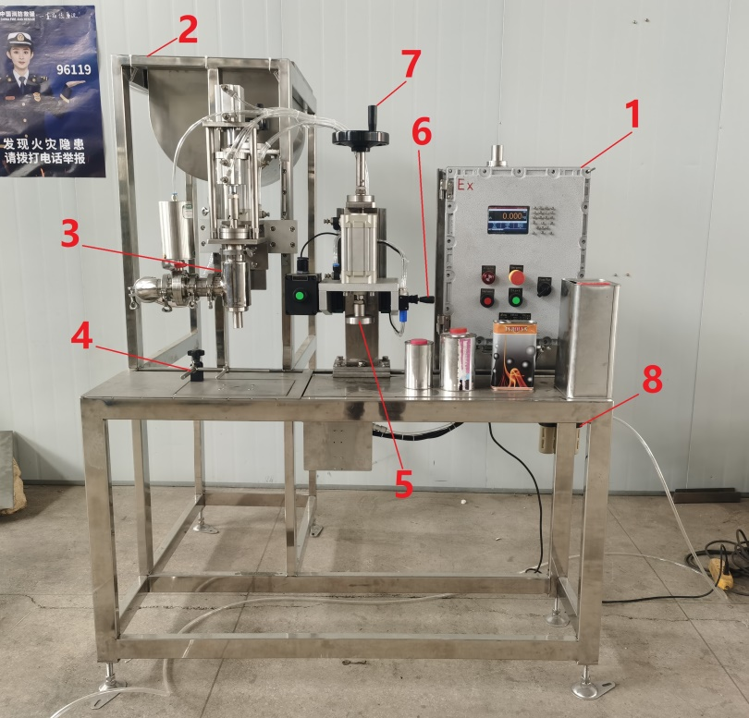
1: Control panel
2: Buffer tank
3: Filling nozzle
4: Container positioner
5: Lid press
6: Handle for lid press operation
7: Handwheel for height adjustment
8: Oil-water separator for air source
9: Air tube for material feed pump/valve
10: Material inlet
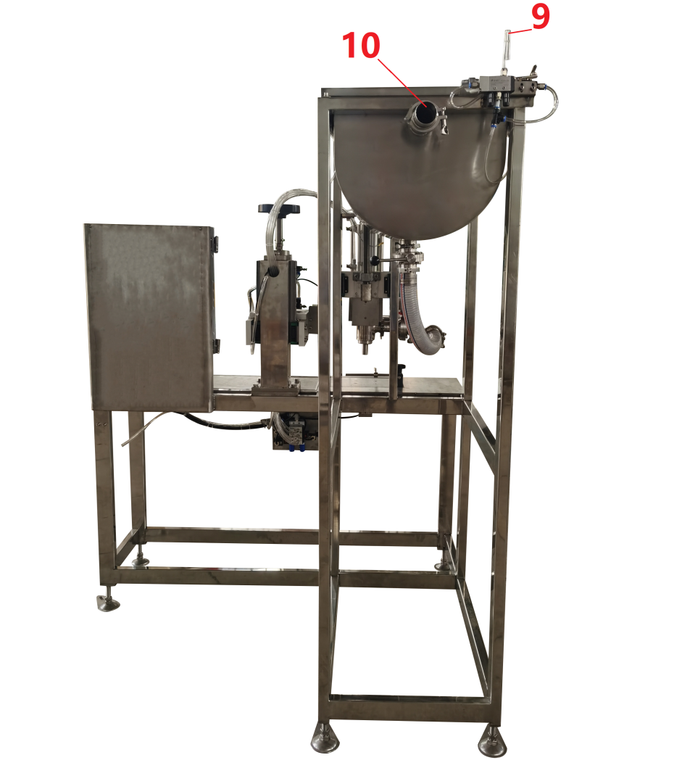
Parts to wash: buffer tank, hose and filling nozzle
The buffer tank is available as an option.
If you don't like it you may connect the hose directly to the storage tank rather than via the buffer tank.
Hose and filling nozzle can be detached with the quick joint at both ends.

- What does “Coarse Flow Remains” refers to and how does it work?
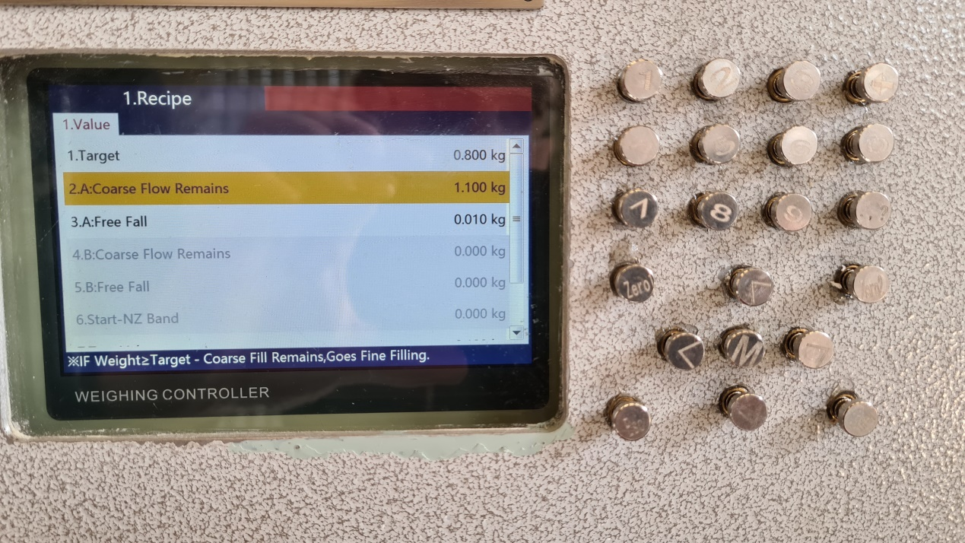
Coarse Flow Remains:
The filling process is divided into 2 steps i.e. coarse fill and fine fill.
E.g. Target: 800g
Coarse Flow Remains: 50g (can be adjusted. Means coarse fill will stop when the actual weight is more than 800-50=750g and fine fill will start.).

- What does “Free Fall” refers to and how does it work?
The Free Fall refers to the difference between the actual weight and the target value.
Conduct the pilot filling for 5 times and record the values. Please note the actual values should be higher than the target value.
Choose the reasonable 3~5 actual values and calculate the average.
Input the average valve as the Free Fall means.
Try to filling again and check if the actual weight is acceptable.
If it is acceptable the setting can be stored. Otherwise, repeat the operation above.

- What does “Tare” refers to? How to set it? How does it work?
It means the weight of an empty container to fill. Choose “Tare” and input the weight value of the container. When the filling machine is in the automatic state, the load cell will automatically detect whether the weight of the empty barrel placed on the weighing platform is within the allowable value range set on the weighing controller. If it is, it will automatically take out the tare weight and start the filling; otherwise, it will not act.

- What does “Tare Tolerance” refers to? How to set it?
Tare Tolerance refers to the allowable error range between the actual weight of the actual containers and the standard value.

- Does this machine work only in free fall mode?
No powered suck or powered push in the filling machine. The filling process goes on by free fall.

- Can the filling speed be adjusted?
The filling speed can be regulated through setting of 2 and 3 on the screen.

- How to set up, modify and store recipes?
In the state of Stop, press 0 in the keyboard area, choose “Administrator”, press “M” and input the default operation password "000000" to enter the “Technician” interface.
Press “M” to enter the user parameter setting interface.
Choose “Recipe” and press “M” (or press the shortcut “5”) to enter the recipe list.
Press “Zero 1” to enter the interface of recipe number.
The recipe number can be chosen, modified, stored and recalled. Max. 20 recipes can be stored.
Choose the recipe you need and press “M” (or press the shortcut “9”) to enter the recipe parameter setting interface.
After finishing the parameter setting, press the Enter key to save the recipe or press the Esc key to abandon the recipe.
- How to calibrate the load cell?
In the user parameter setting interface, choose “Calibration” and input the default operation password "000000" to calibrate the scale.
Remove all loads from the weighing platform, when the weight reads 0.00 press Enter key to Zero the empty weighing platform.
Place a 25kg standard weight on the weighing platform, enter 25.00 on the interface where the reading is displayed on the weighing controller and press Enter key to complete the calibration.

